**Azure boards migration**

Reference link : <https://www.c-sharpcorner.com/article/move-azure-devops-work-items-from-one-organization-to-another>

Install azure devops migration tool: <https://visualstudio.microsoft.com/downloads/#other-family>



Open excel in the excel open Team and > new list add source organization server details

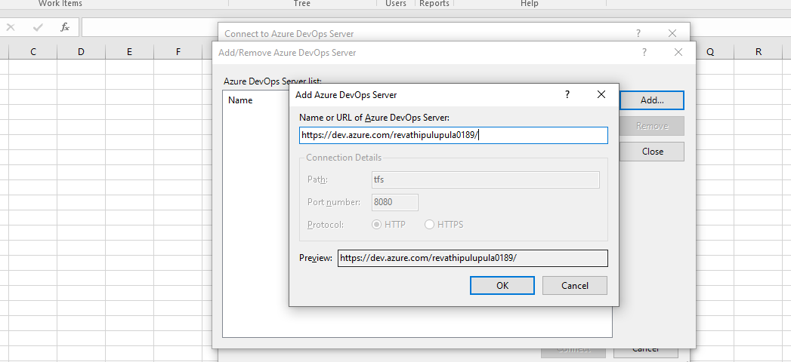

Follow document run query into the source organization

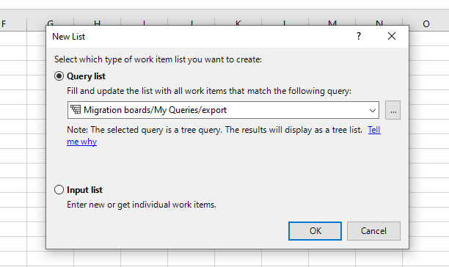

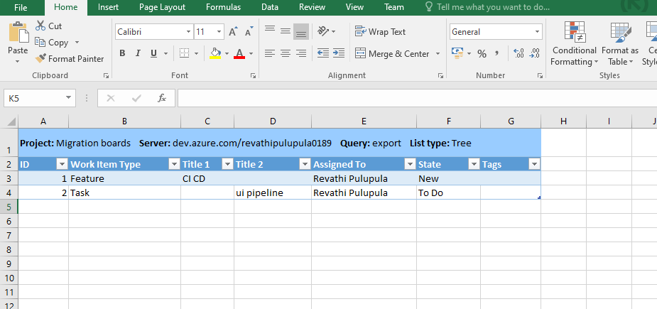

Now open team select id and select choose column refer document 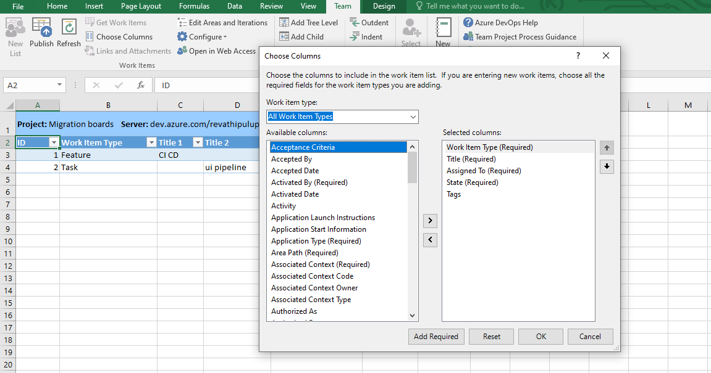follow selected columns into source and destination same as well

Open another excel add destination organization details

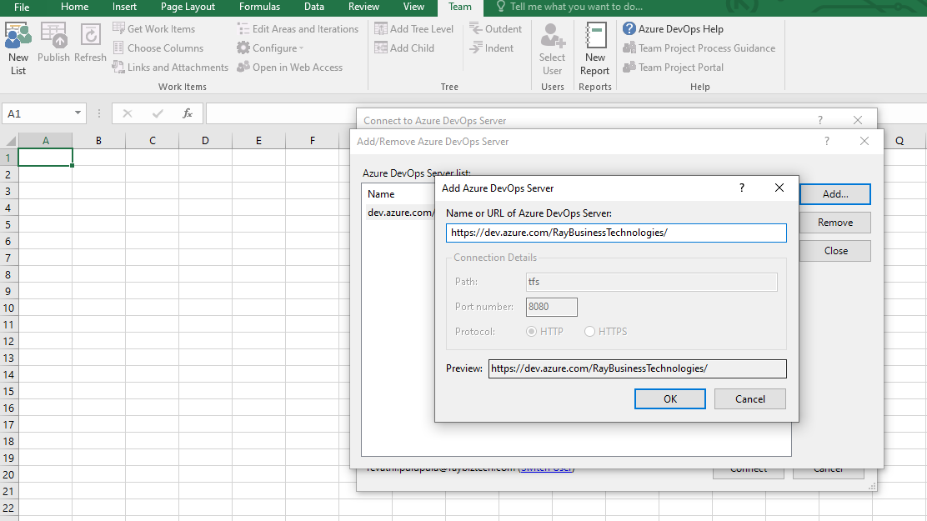

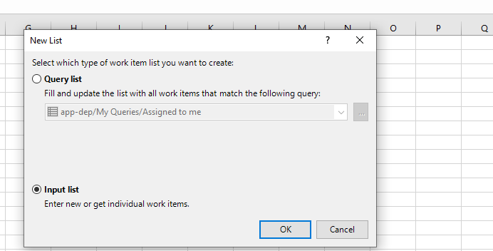

Add tree level refer doc and

Selected columns same as source format

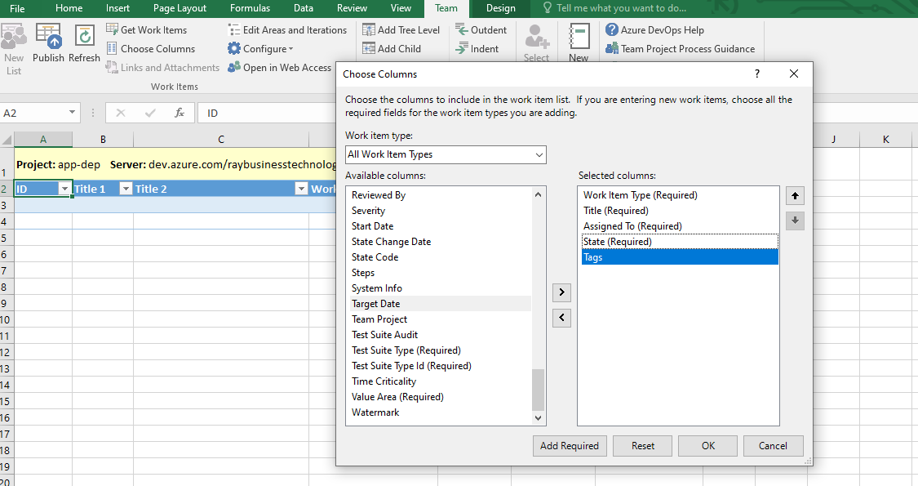

Copy data from source org 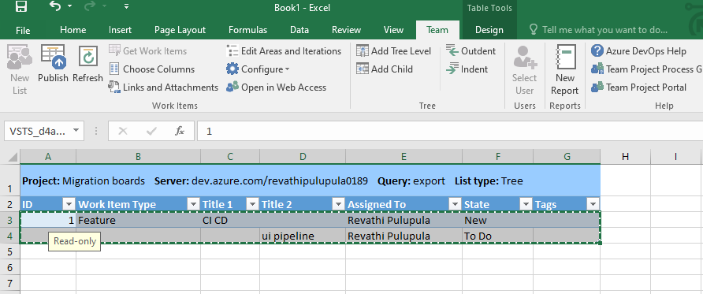

And paste destination org

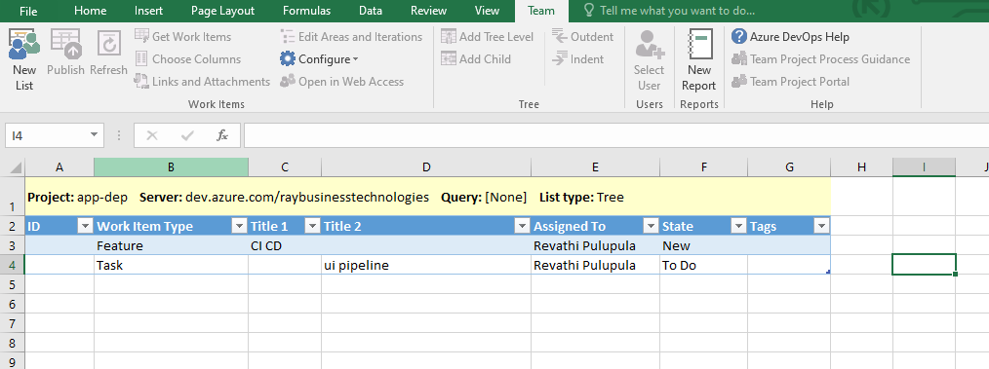and finally select publish

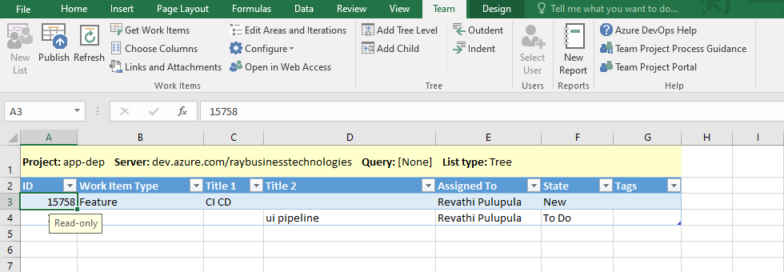

You can see our destination org

